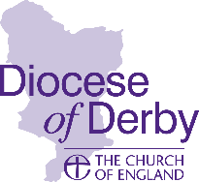
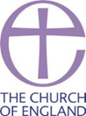
Synodical Government Measure 1969
CHURCH ELECTORAL ROLL CERTIFICATE

Parish of

in the deanery of and the Diocese of Derby.

I hereby certify that the number of names entered upon the Church Electoral Roll of the above parish, as revised in preparation for the Annual Parochial Church Meeting held in the year 2024, was

Date ............................. Signed.................................
Full Name..................................................................
Chair / Vice-Chair / Secretary / Electoral Roll Officer (delete as appropriate)
Notes:
1. This certificate is to be signed by the chair, vice-chair, secretary or church electoral roll officer of the parochial church council.
2. A copy of this certificate must also be affixed, for a period of not less than 14 days, on or near the principal door of every church and building licensed for public worship in the parish.
3. Return a copy of this completed form, along with your APCM Results of Election form, as soon as possible and no later than the deadline of 31 May 2024 to:
PCC Results c/o Diocesan Secretary
Church House Derby
Full Street
Derby
DE1 3DR
or email to PCCResults@derby.anglican.org

