PREDATORY MARRIAGE – DAPHNE FRANKS

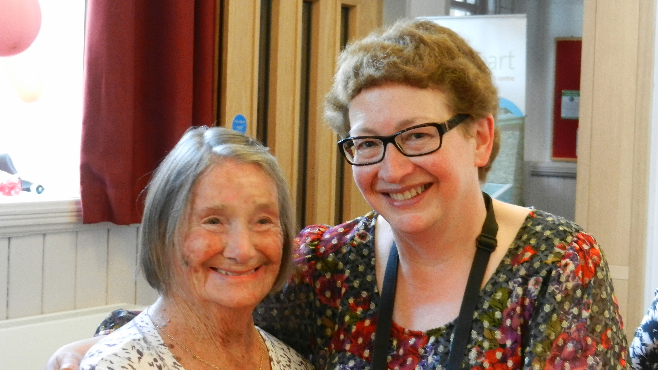

Joan Blass and Daphne Franks at Joan’s 90th Birthday Party, April 2014

Please watch the documentary about our story – the third in the series “Inheritance Wars: Who Gets the Money” – Channel Five, 9pm, October 1, 2023 and on Channel Five catch-up after that

“Your mother and her man friend – did you know they were married?”
So, with a phone call from Joan Blass’s doctor, began a horrific series of events which have highlighted the gaps in safeguarding for the elderly and the vulnerable, both at the time of marriage and in the Law.

In March 2016 Joan Blass was almost 92 years old, with severe vascular dementia and terminal cancer. She was unable to make the simplest decision and never knew that she had remarried just five months before her death.

Joan’s daughter Daphne Franks tells the story of a secret marriage, a revoked will, an unmarked grave, grooming, gaslighting, a Private Member’s Bill and a campaign to highlight all the issues. The Franks family hope to fill all the gaps so nothing like this will ever happen to another family in the future – because, as they have learned, it’s currently happening to many of our elderly and vulnerable and their families.

This story is “right up there amongst the most shocking we’ve come across in the ten years that we’ve been making this programme.” - Angela Rippon, Rip-Off Britain, BBC Television.

Daphne Franks, 67, is a teacher who worked at Leeds Medical School for many years, teaching Communication Skills and other non-clinical courses. She is still teaching freelance part-time.
Daphne now lives in Newcastle, Tyne and Wear, with her husband Stephen, son Oliver, daughter-in-law Alex and adorable granddaughter Linnet, two!

Issues with current safeguards*:
• If the victim has set up a power of attorney, the attorney is not notified if the victim marries.
• Notifications of marriage are displayed on notice boards in register offices and are not easily searchable or listed online.
• No evidence is kept at the point of marriage – no video or audio recordings – once a marriage certificate is attained the following impact on wills is almost impossible to challenge.
• Registrars have responsibility for judgment of mental capacity on the day. These persons may not have training on dementia or mental capacity.
• There is an absence of joined up safeguarding between different relevant organisations and an absence of standardised safeguarding or mental capacity training.

(* Credit: Hourglass March 2022)

www.predatorymarriage.uk
www.justiceforjoan.com
facebook.com/predatorymarriage
info@predatorymarriage.uk

