Name of parish

Diocese of Derby

The Eucharist with
Baptism & Confirmation

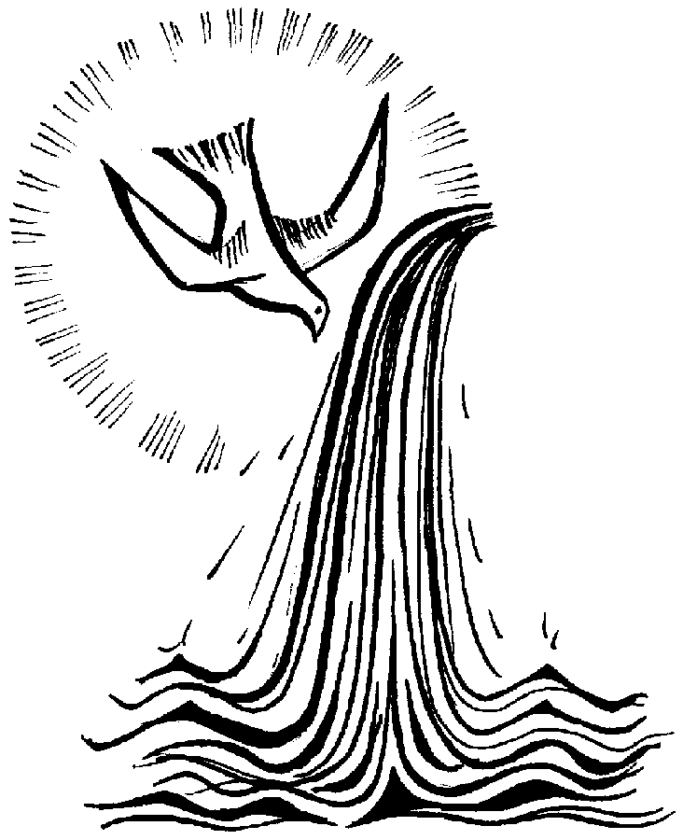

Date
Time
The Gathering
Stand

At the entry of the Bishop, ministers and servers the Entrance hymn is sung.

Please put at the end of all the hymns the composer, and either their date of birth or the copyright (this info can be found in your hymn book)

The Greeting
Stand
Bishop In the name of the Father and of the Son
and of the Holy Spirit.
All Amen

Bishop Blessed be God, Father, Son and Holy Spirit.
All Blessed be his kingdom, now and for ever. Amen

From Easter Day to Pentecost
Bishop Alleluia! Christ is risen.
All He is risen indeed. Alleluia!

Bishop There is one body and one spirit
All There is one hope to which we were called.

Bishop One Lord, one faith, one baptism,
All One God and Father of all.

Bishop Peace be with you

All And also with you.

The Bishop introduces the service

The Gloria

Stand

All Glory to God in the highest,
and peace to his people on earth.

Lord God, heavenly King,
almighty God and Father,
we worship you, we give you thanks,
we praise you for your glory.

Lord Jesus Christ, only Son of the Father,
Lord God, Lamb of God,
you take away the sin of the world:
have mercy on us;
you are seated at the right hand of the Father:
receive our prayer.

For you alone are the Holy One,
you alone are the Lord,
you alone are the Most High, Jesus Christ,
with the Holy Spirit,
in the glory of God the Father. Amen.

The Collect
Stand
The Collect of the Day is normally used on Sundays, Principal Feasts, other Principal Holy Days and Festivals. On other occasions a seasonal collects, or this Collect is used

Bishop Let us pray

Silence may be kept

Heavenly Father,
by the power of your Holy Spirit
you give to your faithful people new life in the water of baptism.
Guide and strengthen us by the same Spirit,
that we who are born again may serve you in faith and love,
and grow into the full stature of your Son, Jesus Christ,
who is alive and reigns with you in the unity of the Holy Spirit
now and for ever.
All Amen

The Liturgy of the Word

Sit

First Reading
Bible reference here

Please put full text of readings. NRSV preferred.

The readings of the day are normally used on Sundays, Principal Feasts, other Principal Holy Days and Festivals.

Either one or two readings from Scripture may precede the Gospel reading.

Reader This is the word of the Lord.
All Thanks be to God.

We stand to greet the Gospel by singing

The Gradual Hymn
Stand

Gospel Acclamation

Alleluia, alleluia.

Your words are spirit, Lord, and they are life.

All Alleluia!

The Gospel
Stand

The Lord be with you.

All And also with you.

Hear the Gospel of our Lord Jesus Christ according to name of gospel writer (reference)
All Glory to you, O Lord.

Put text of reading of the day here. NRSV preferred

This is the Gospel of the Lord.
All Praise to you, O Christ.

The Sermon
Sit
Put name and details of preacher here

Liturgy of Initiation

The bishop asks the candidates for baptism and confirmation to stand

Presentation of the Candidates
Sit
The candidates are presented to the congregation, who remain seated.

The bishop asks those who are candidates for baptism

Do you wish to be baptized?
Candidates I do.

The bishop asks the candidates for confirmation who have been baptized

Have you been baptized in the name of the Father, and of the Son, and of the Holy Spirit?
Candidates I have.

The bishop asks all the candidates

Are you ready with your own mouth and from your own heart to affirm your faith in Jesus Christ?
Candidates I am.

The bishop addresses the whole congregation

Faith is the gift of God to his people.
In baptism the Lord is adding to our number those whom he is calling.
People of God, will you welcome these candidates and uphold them in their life in Christ?
All With the help of God, we will.

The Decision
Sit

The bishop addresses all the candidates

Bishop In baptism, God calls us out of darkness into his marvellous light.
To follow Christ means dying to sin and rising to new life with him.
Therefore I ask:

Do you reject the devil and all rebellion against God?
Candidates I reject them.

Do you renounce the deceit and corruption of evil?
Candidates I renounce them.

Do you repent of the sins that separate us from God and neighbour?
Candidates I repent of them.

Do you turn to Christ as Saviour?
Candidates I turn to Christ.

Do you submit to Christ as Lord?
Candidates I submit to Christ.

Do you come to Christ, the way, the truth and the life?
Candidates I come to Christ.

Signing with the Cross
Sit

The parish priest of those to be baptised anoints those to be baptised with the oil of Catechumens with the sign of the cross on the forehead, saying

Christ claims you for his own.
Receive the sign of his cross.

When all the candidates for baptism have been signed, the bishop says to them

Do not be ashamed to confess the faith of Christ crucified.
All Fight valiantly as a disciple of Christ
against sin, the world and the devil,
and remain faithful to Christ to the end of your life.

The bishop then says
May almighty God deliver you from the powers of darkness,
restore in you the image of his glory,
and lead you in the light and obedience of Christ.
All Amen.

Procession to the Font
Stand

We stand, turn and face the font as the bishop and candidates process to the font. We sing the following hymn or quiet music is played

Prayer over the Water
Stand
The bishop and candidates for baptism and confirmation gather at the baptismal font.

The bishop stands before the water of baptism and says

Bishop Praise God who made heaven and earth,
All Who keeps his promise for ever.

Let us give thanks to the Lord our God.
All It is right to give thanks and praise.

We thank you, almighty God, for the gift of water
to sustain, refresh and cleanse all life.
Over water the Holy Spirit moved in the beginning of creation.
Through water you led the children of Israel
from slavery in Egypt to freedom in the promised land.
In water your Son Jesus received the baptism of John
and was anointed by the Holy Spirit as the Messiah,
the Christ,
to lead us from the death of sin to the newness of life.

We thank you, Father, for the water of baptism.
In it we are buried with Christ in his death.
By it we share in his resurrection.
Through it we are reborn by the Holy Spirit.
Therefore, in joyful obedience to your Son,
we baptise into his fellowship those who come to him in faith.

Now sanctify this water that, by the power of your Holy Spirit,
they may be cleansed from sin and born again.
Renewed in your image, may they walk by the light of faith
and continue for ever in the risen life of Jesus Christ our Lord;
to whom with you and the Holy Spirit
be all honour and glory, now and for ever.
All Amen.

Profession of Faith
Stand

The bishop addresses the candidates and the congregation to renew their own baptismal profession of faith.

Bishop Brothers and sisters, I ask you to profess
together with these candidates
the faith of the Church.

Do you believe and trust in God the Father?
All I believe in God, the Father almighty,
creator of heaven and earth.

Do you believe and trust in his Son Jesus Christ?
All I believe in Jesus Christ, his only Son, our Lord,
who was conceived by the Holy Spirit,
born of the Virgin Mary,
suffered under Pontius Pilate,
was crucified, died, and was buried;
he descended to the dead.
On the third day he rose again;
he ascended into heaven,
he is seated at the right hand of the Father,
and he will come to judge the living and the dead.

Do you believe and trust in the Holy Spirit?
All I believe in the Holy Spirit,
the holy catholic Church,
the communion of saints,
the forgiveness of sins,
the resurrection of the body,
and the life everlasting. Amen.

The Baptism
Stand

The bishop addresses each candidate for baptism by name, saying
N, is this your faith?

The candidate answers
Candidate This is my faith.

The bishop then pours water on their head, saying

N, I baptize you
in the name of the Father,
and of the Son,
and of the Holy Spirit.
All Amen.

The bishop says this prayer

Almighty God,
we thank you for our fellowship in the household of faith
with all who have been baptised into your name.
Keep us faithful to our baptism,
and so make us ready for that day
when the whole creation shall be made perfect in your Son,
our Saviour Jesus Christ.
All Amen.

The Sprinkling
Stand
The bishop invites each candidate to dip their finger in the font and make the sign of the cross. He then sprinkles all present with the baptismal water as a reminder of their own baptism. When the congregation has been sprinkled, the bishop says the following prayer

Bishop Almighty God,
we thank you for our fellowship in the household of faith
with all who have been baptized into your name.
Keep us faithful to our baptism,
and so make us ready for that day
when the whole creation shall be made perfect in your Son,
our Saviour Jesus Christ.
All Amen.

The bishop and the candidates gather in the Nave during the singing of the following hymn (or another suitable hymn)

1. Holy Spirit, come, confirm us
in the truth that Christ makes known;
we have faith and understanding
through your helping gifts alone.

2 Holy Spirit, come, console us,
come as Advocate to plead,
loving Spirit from the Father,
grant in Christ the help we need

3 Holy Spirit, come, renew us,
come yourself to make us live,
holy through your loving presence,
holy through the gifts you give.

4 Holy Spirit, come, possess us,
you the love of Three in One,
Holy Spirit of the Father,
Holy Spirit of the Son
B. Foley b. 1919-2000 Tune; All For Jesus

The Confirmation

Sit
The bishop stands before those who are to be confirmed, and says

Our help is in the name of the Lord
All who has made heaven and earth.

Blessed be the name of the Lord
All now and for ever. Amen.

The bishop extends his hands towards those to be confirmed and says

Almighty and ever-living God,
you have given these your servants new birth
in baptism by water and the Spirit,
and have forgiven them all their sins.
Let your Holy Spirit rest upon them:
the Spirit of wisdom and understanding;
the Spirit of counsel and inward strength;
the Spirit of knowledge and true godliness;
and let their delight be in the fear of the Lord.
All Amen.

The bishop addresses each candidate by name and anoints them with Holy Oil

N, God has called you by name and made you his own.

He then lays his hand on the head of each, saying

Confirm, O Lord, your servant with your Holy Spirit.
All Amen.

The bishop invites the congregation to pray for all those who have been confirmed

All Defend, O Lord,
these your servants with your heavenly grace,
that they may continue yours for ever,
and daily increase in your Holy Spirit more and more
until they come to your everlasting kingdom. Amen.

The candidates return to their seats

The Welcome and the Peace
Stand

The bishop addresses the newly baptised

There is one Lord, one faith, one baptism:
N, by one Spirit we were all baptised into one body.

All We welcome you into the fellowship of faith;
We are children of the same heavenly Father;
We welcome you.

The bishop introduces the Peace (Seasonal provisions can be used)

God has made us one in Christ.
He has set his seal upon us
and as a pledge of what is to come
has given the Spirit to dwell in our hearts.

The peace of the Lord be always with you.
All And also with you.

Let us offer one another a sign of peace.

All may exchange a sign of peace.

The Liturgy of the Eucharist

During the Offertory hymn a collection is taken and the bread and wine are brought to the Altar

The Prayer over the Gifts

Stand
Bishop Creator of all,
You wash away our sins,
You give us new birth by the Spirit,
And redeem us in the blood of Christ.
As we celebrate this Eucharist,
Renew your gift within us.
We ask this in the name of Christ the risen Lord.
All Amen

The Eucharistic Prayer
Stand
Bishop The Lord be with you.
All And also with you.
Bishop Lift up your hearts.
All We lift them to the Lord.

Bishop Let us give thanks to the Lord our God.
All It is right to give thanks and praise.
Father, we give you thanks and praise
through your beloved Son Jesus Christ, your living Word,
through whom you have created all things;
who was sent by you in your great goodness to be our Saviour.

By the power of the Holy Spirit he took flesh;
as your Son, born of the blessed Virgin,
he lived on earth and went about among us;
he opened wide his arms for us on the cross;
he put an end to death by dying for us;
and revealed the resurrection by rising to new life;
so he fulfilled your will and won for you a holy people.

And now we give you thanks
because by water and the Holy Spirit
you have made us a holy people in Jesus Christ our Lord;
you raise us to new life in him
and renew in us the image of your glory.

Therefore with angels and archangels,
and with all the company of heaven,
we proclaim your great and glorious name,
for ever praising you and saying:

Sanctus and Benedictus (said or sung)

Holy, holy, holy Lord,
God of power and might,
Heaven and earth are full of your glory.
Hosanna in the highest.

Blessed is he who comes in the name of the Lord.
Hosanna in the highest.

The bishop recalls the Last Supper

Lord, you are holy indeed, the source of all holiness;
grant that by the power of your Holy Spirit,
and according to your holy will,
these gifts of bread and wine
may be to us the body and blood of our Lord Jesus Christ;
who, in the same night that he was betrayed,
took bread and gave you thanks;
he broke it and gave it to his disciples, saying:
Take, eat; this is my body which is given for you;
do this in remembrance of me.
In the same way, after supper
he took the cup and gave you thanks;
he gave it to them, saying:
Drink this, all of you;
this is my blood of the new covenant,
which is shed for you and for many for the forgiveness of sins.
Do this, as often as you drink it,
in remembrance of me.

Eucharistic Acclamation (said or sung)

Great is the mystery of faith.

All Christ has died
Christ is risen
Christ will come again

And so, Father, calling to mind his death on the cross,
his perfect sacrifice made once for the sins of the whole world;
rejoicing in his mighty resurrection and glorious ascension,
and looking for his coming in glory,
we celebrate this memorial of our redemption.
As we offer you this our sacrifice of praise and thanksgiving,
we bring before you this bread and this cup
and we thank you for counting us worthy
to stand in your presence and serve you.
Send the Holy Spirit on your people
and gather into one in your kingdom
all who share this one bread and one cup,
so that we, in the company of Insert saints names here
And all the saints,
may praise and glorify you for ever,
through Jesus Christ our Lord;
by whom, and with whom, and in whom,
in the unity of the Holy Spirit,
all honour and glory be yours, almighty Father,
for ever and ever.
All Amen.

The Lord’s Prayer
Stand
Let us pray with confidence as our Saviour taught us.

All Our Father, who art in heaven;
hallowed be thy name;
Thy kingdom come, thy will be done,
on earth as it is in heaven.
Give us this day our daily bread
and forgive us our trespasses,
as we forgive those who trespass against us,
and lead us not into temptation,
but deliver us from evil.
For thine is the kingdom
the power and the glory,
for ever and ever. Amen.
Breaking of the Bread
Stand
The bishop breaks the consecrated bread.

We break this bread
to share in the body of Christ.
All Though we are many, we are one body,
because we all share in one bread.

Agnus Dei (said or sung)
Stand
Lamb of God,
you take away the sin of the world,
have mercy on us.

Lamb of God,
you take away the sin of the world,
have mercy on us.

Lamb of God,
you take away the sin of the world,
grant us peace.

The Invitation to Communion
Stand

Bishop Jesus is the Lamb of God
who takes away the sin of the world;
Blessed are those who are called to his supper.
All Lord, I am not worthy to receive you,
but only say the word and I shall be healed.

Giving of Communion

The Church of England welcomes to Holy Communion baptised and communicant members of other Trinitarian churches who are in good standing with their own community. Anyone unable to receive Holy Communion is invited to come forward for a blessing. Please keep your head bowed and your hands joined to indicate you wish to receive a blessing.

Please come to receive communion or a blessing as directed

During the distribution of Communion, the Communion Hymns are sung.

Prayer after Communion
Stand
The authorized Post Communion of the Day is normally used on Sundays, Principal Feasts, other Principal Holy Days and Festivals. On other occasions a seasonal Post Communion, or the following is used

Let us pray
Silence is kept.
God of mercy,
by whose grace alone we are accepted
and equipped for your service:
stir up in us the gifts of your Holy Spirit
and make us worthy of our calling;
that we may bring forth the fruit of the Spirit
in love and joy and peace;
through Jesus Christ our Lord.
All Amen.

The Sending Out

The Commission
Stand

The bishop commissions the newly baptized and confirmed for their life of worship, witness, and service.

Bishop Those who are baptized and confirmed are called to worship and serve God.

Will you continue in the apostles’ teaching and fellowship,
in the breaking of bread, and in the prayers?
All With the help of God, I will.

Will you persevere in resisting evil,
and, whenever you fall into sin, repent and return to the Lord?
All With the help of God, I will.

Will you proclaim by word and example
the good news of God in Christ?
All With the help of God, I will.

Will you seek and serve Christ in all people,
loving your neighbour as yourself?
All With the help of God, I will.

Will you acknowledge Christ’s authority over human society,
by prayer for the world and its leaders,
by defending the weak, and by seeking peace and justice?
All With the help of God, I will.

May Christ dwell in your hearts through faith,
that you may be rooted and grounded in love
and bring forth the fruit of the Spirit.
All Amen.

The Blessing
Stand
Bishop Our help is in the name of the Lord.
All Who has made heaven and earth.

Bishop Blessed be the name of the Lord.
All Henceforth, world without end.

The God of all grace,
who called you to his eternal glory in Christ Jesus,
establish, strengthen and settle you in the faith;
and the blessing of God almighty,
the Father, the Son, and the Holy Spirit,
be among you and remain with you always..
All Amen

Giving of a Lighted Candle
Stand
The newly baptised and confirmed receive a lighted candle, lit from the Paschal Candle. When all have received a candle, the bishop says

God has delivered us from the dominion of darkness
and has given us a place with the saints in light.

You have received the light of Christ;
walk in this light all the days of your life.
All Shine as a light in the world
to the glory of God the Father.

The Dismissal
Stand

Go in the light and peace of Christ. Alleluia. Alleluia!
All Thanks be to God. Alleluia. Alleluia!

During the Recessional Hymn, the bishop may lead the newly confirmed through the church

Common Worship: Christian Initiation, material from which is included in this service, is copyright© The Archbishops’ council 2006

Music in this order of service is reproduced under license CCL no. …..insert copyright number

