Go into all the world and proclaim the gospel to the whole creation.
Pictures from June Diocesan Synod 2018. The placards show the answer to the question- what are the implications of the five marks of mission? What does it impact?
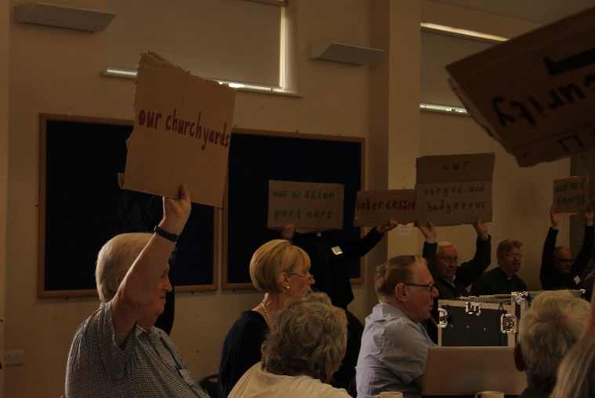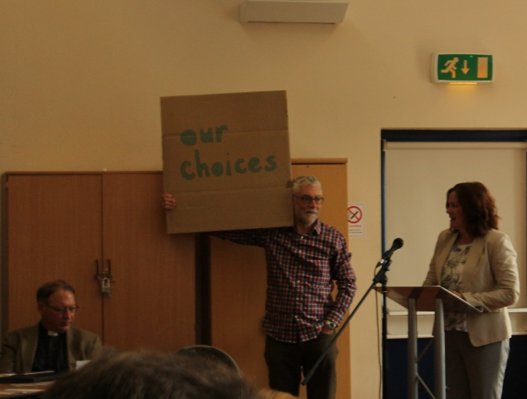
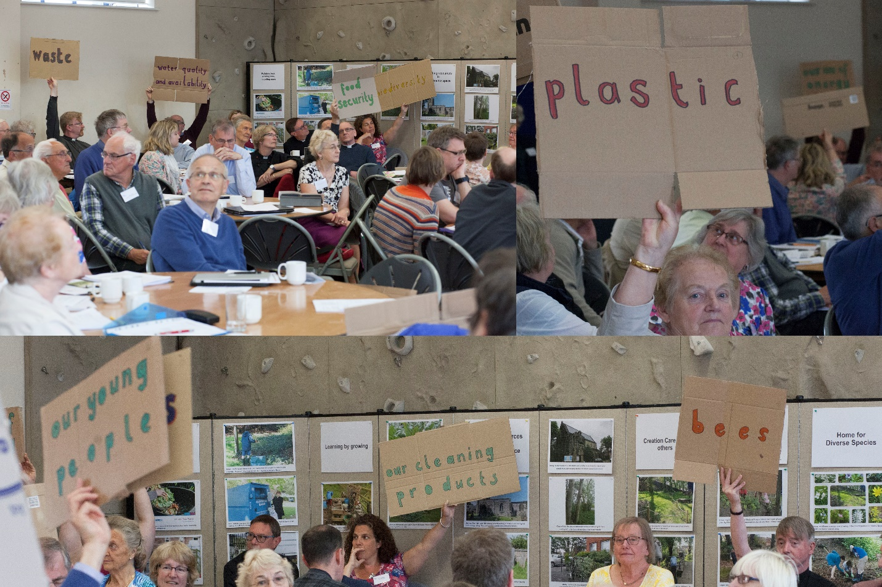
There is delightful news that at Diocesan Synod in June Derby agreed to become an Eco Diocese. So we have a renewed mandate to encourage parishes, fresh expressions of church and church leaders and members to work towards becoming Eco Churches so together we achieve an Eco Diocese award. Thank you to many people who supported this from parishes and schools around the county and of course to Bishop Alastair and his committee for taking this item on the agenda.
Practically working towards this will be easier for those with resources of finance, health and lack of obligations such as caring commitments. However, all of us can take this as a challenge to do something for the good of the earth and share how it influence our choices. Of course, this is not a new thing since the fifth mark of mission (1996) is ‘to strive to safeguard the integrity of creation and sustain and renew the life of the earth’. Perhaps you realise, as I do, the old criticism of those of us who follow Christ and call ourselves Christians is never more true in this respect - we are all hypocrites. We claim to want to bring the good news of the gospel, the best for the poorest people on the earth, we regularly give to missionary endeavours in poorer countries and at home to those who are marginalised, we work for justice or serve in our own church, but we haven’t adjusted our lifestyles to the need to care for all creation. We are hypocrites because we love new things, updated and fashionable things, collections of things and things that get us to where we want to go faster and more comfortably using up more than our share of the earth’s resources. So how can we begin to arrest this? I think it is by making it part of our Christian discipleship and witness and the weft and warp of our Christian lives.
May I suggest that we are singing the wrong songs? So many tell about our personal salvation and experience of God, often using images of war and adversaries pertinent in commemorations and when there was a world war but not so much today. We can also develop the use metaphors of community and gathering (as we often are when we sing), and songs of thanks to Creator God and the beauty of the world, even though we have exploited it. Could our poets and songwriters use this theology to help us tackle this and turn from selfishness, greed, jealousy and our limited ability to share and not put ‘me first’. Or perhaps we have these songs and poems and don’t enjoy the challenge of them and their visible battles.
To respond to those of you that think this takes us away from our imperative to evangelism and our great calling to make disciples across the world - let me remind you of the less commonly quoted version of that great commission, in Mark 16 verse 15, ‘Go into all the world and proclaim the gospel to the whole creation.’ Doesn’t that sound unfamiliar? And, if in preaching and teaching the redeeming grace to the world of people we neglect the gospel to the rest of creation we have missed a great big piece of the point. In fact, that neglect has impacted the power of the message of good news to many of the people who are most impacted by climate change through features like flood, hurricane and more locally fire, drought and earthquake. So, don’t just read this – do something. May I plead with you to share what you do? As we share our story we can share our progress and ideas so we feel we are part of this together.
Stella Collishaw

Written with grateful thanks to the writings of Dave Bookless, Planetwise. Dare to Care for God’s World, IVP (2008).
To become an Eco Church register at https://ecochurch.arocha.org.uk/
To ask for advice, to borrow the display from Diocesan Synod for your local event, to borrow recommended resources, or to share your news e: Stella.Collishaw@derby.anglican.org or tel contact 01332 388685. To view the film from Synod see http://www.derby.anglican.org/en/our-mission/environment.html where you will also find our latest resources and news.

Eternal God,
whose Spirit moved over the face of the deep bringing forth light and life;
by that same Spirit, renew your creation, and restore your image in your people.
Turn us from careless tenants to faithful stewards,
that your threefold blessing of clean air, pure water and rich earth
may be the inheritance of everything that has the breath of life
and one generation may proclaim to another the wonder of your works;
through Jesus Christ, your living Word,
in whom the fullness of your glory is revealed.
Amen.

Rt Revd Libby Lane
Bishop of Stockport
From prayers for World Environment Day
https://www.churchofengland.org/prayer-and-worship/topical-prayers/prayers-world-environment-day

