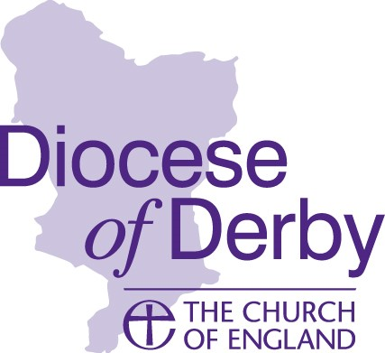

DERBY DIOCESAN BOARD OF FINANCE

Raymond Ross Fund – Large Grants

Following the receipt of a legacy from a former Chair of the Diocesan Advisory Committee, Bishop's Council have established a fund to be made available to parishes in a simple scheme designed to help them with their local mission tasks.
The fund offers parishes an exciting opportunity to develop their local church or hall premises, making them more community and mission shaped, and accessible to people of all ages and abilities.
Your project needs to meet outcomes which achieve and support mission, community or growth. A preference will be given to applications from parishes in deprived areas of the Diocese.
The maximum grant available will be £25,000 and requires match funding. Parishes will be required to take up grants within two years of a successful application.
Applications will be assessed by the Business Committee on a quarterly basis.

NB: If your project is of a much smaller scale, you could alternatively apply to the Raymond Ross £5k small grants scheme launched in February 2020 – this scheme does not require any match funding.

CRITERIA FOR GRANTS
You should ensure that your application meets as nany of the following conditions as possible:
- Imaginative schemes with full PCC support
- Local church and community contributions
- Church premises with strategic, long term future
- Single capital projects, not routine repairs or salaries
- Projects attracting matching funding from other sources
- Churches with minimal existing resources and reserves
- Support of the Deanery Synod Standing Committee
- Commitment to contribute toward the Common Fund
- Full disclosure of all parish accounts
- Compliance with Faculty Jurisdiction, disability legislation etc. where applicable
- Mission of the church in the community articulated by the PCC
- Only one application per parish

APPLICATION FORMS, ADVICE, CONTACT NUMBERS
Completed applications should be addressed to:

Raymond Ross Fund,
Mission & Ministry Team,
Derby Church House,
1 Full Street,
Derby, DE1 3DR

Or emailed to gareth.greenwood@derby.anglican.org

Applications will only be considered with authorising signatures and accompanied by full supporting documentation.

Further assistance can be sought from Gareth Greenwood, Community Project Development Officer, who will also gladly advise parishes at an early stage of developing project plans, to include community engagement and at later stages with regard funding possibilities.

Email: gareth.greenwood@derby.anglican.org Tel: 01332 388690

